Team Name:

* Omedi

Team Members:

* Dilan Kaya
* Osman Melih Tolunay
* Umut Şentürk
* Mustafa Körükmez

Main Contact for the Instructor:

* Mustafa Körükmez

Instructor:

* Ahmet Çağdaş Seçkin

TEAM INFORMATIONS:

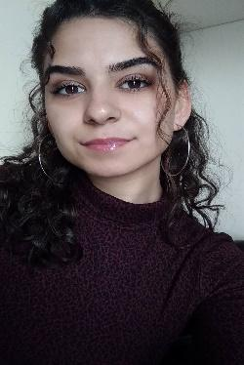

* **Dilan Kaya**
* Mail: [dilankayaa16@gmail.com](mailto:dilankayaa16@gmail.com)
* Phone Number: 05536817398
* I'm available at any time during the day for response.

Biography:

Dilan Kaya, I was born on 15th March 1998 in Antalya. I went to primary school in Hüseyin Avni Çöllü and high school in Serik Atatürk Anatolian High School. I had an accident in 2014 and I gave a break to my education for a year and graduated from Private Maarif Anatolian High School. I won Adnan Menderes University, but I studied at Akdeniz University for two years due to a special situation. I came to Adnan Menderes University in 2019 and continue my education. I started programming when I won the university.

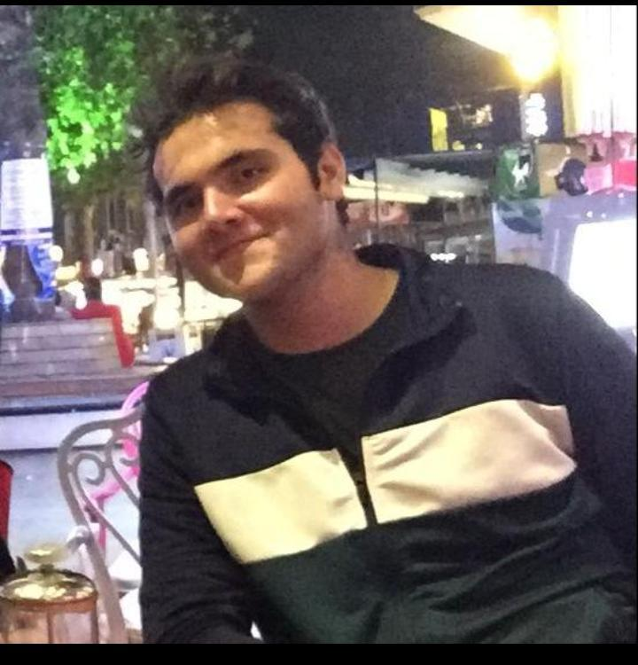

* **Osman Melih Tolunay**
* Mail: [omelihtolunay@gmail.com](mailto:omelihtolunay@gmail.com)
* Phone Number:05432898092
* I'm available at any time during the day for response

Biography:

Osman Melih Tolunay, I was born on 4th August 1999 in Burdur.Till high school graduation I had been living in Burdur Bucak. When I was 10 -12 years old I started to make some bots for RPG games and this is how I started programming. After that I started to make some UI designs with some script languages. When I was 17 years old I started studying about Linux, cyber security and ethical hacking. For 2 years

(beginning of university) I am working on NLP and Linguistics so, I have been studying on some computer systems for a long time. Also, I worked in some freelancer jobs and some companies in different positions.

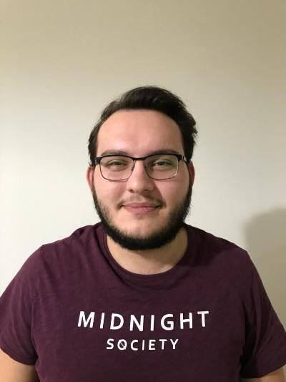

* **Umut Şentürk**
* Mail: 181805049@stu.adu.edu.tr
* Phone Number:05422112641
* I'm available at any time during the day for response

Biography:

Umut Şentürk has grown up intimate with technology since childhood. He was fascinated once he bought his 1st computer at age 7. Although he used the computer as a child to play games and have fun, he realized that he could live the rest of his life working on computers in his in youth, so he decided to study on computers. Therefore He receiveing his education at the University of Adnan Menderes on computer engineering. Umut first started his software language learning with c and is currently developing projects by trying to learn java and python.

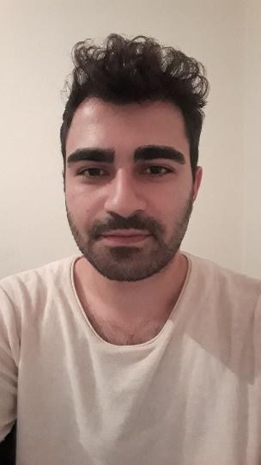

* **Mustafa Körükmez**
* Mail: 181805059@stu.adu.edu.tr
* Phone Number:05389173606
* I’m available at any time during the day for response

Biography:

Mustafa Körükmez has been living a life intertwined with technology since his childhood. His interest in technology increased with the magazines he was a member of from the primary school, and later, with the computer he acquired, he had the opportunity to deal with technology not only as a reader but also as a user. During his high school years, he realized that he was more interested in physics and computers and decided that he had to make a choice. He used his decision in favor of software. Adnan Menderes University computer engineering student now knows C, Java and Python at the entry level and the learning process continues.

Team Rules:

1. Our meetings will be via on Zoom.
2. We set the time to meet during the day. We decided to continue the meeting one day apart. [This is our meeting image.](http://../../../Ekran%20g%C3%B6r%C3%BCnt%C3%BCs%C3%BC%202020-11-06%20202541.png)
3. We will use version Control 1 File is already uploaded to Github. After 2nd control.
4. Dilan will take care of the organizing a meeting day, taking notes and management. Melih will take care of the software and the nlp part. Umut will take care of the promotion and design of the project. Mustafa will also be interested in communicating with the instructor and helping those who need help in the group. Each team member should also help each other when necessary.
5. Dilan will deliver this part on November 5th via Github.
6. If there is a member who wants to leave the team, leaving the project, he / she should give at least 2 days notice. He should leave the team after submitting the documents on the project. And the remaining work should be divided among the remaining members.
7. Github : <https://github.com/dilankya/omedi>
8. Here our team Picture:

